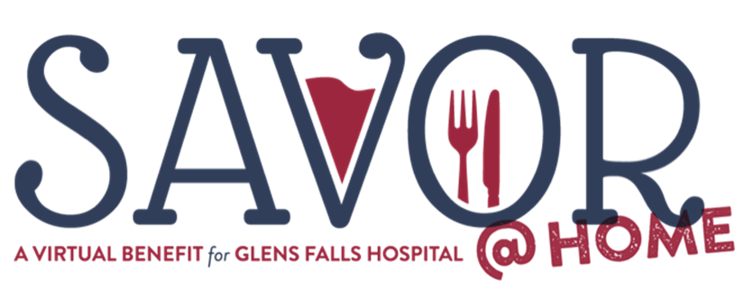
Join us from the comfort of your home on Wednesday, September 23 for SAVOR @ Home, a virtual benefit for Glens Falls Hospitals’ COVID-19 Support Fund where we’ll be premiering a new documentary called, Behind the Masks; Stories of care, compassion and innovation at Glens Falls Hospital during the Coronavirus Pandemic.
Presenting Sponsor - Behan Communications

Executive Chef Sponsor - $15,000
Opportunity to run a 15-30 second commercial during virtual event. (Company provided video)
Listed on event landing page and on social media posts
Twelve gift certificates of $200 each to select area restaurants
Name listed on closing credits

Head Chef Sponsor - $10,000
Opportunity to run a 15-30 second commercial during virtual event. (Company provided video)
Listed on event landing page and on social media posts
Eight gift certificates of $200 each to select area restaurants
Name listed on closing credits
Sous Chef Sponsor - $5,000
Logo/name listed as sponsor of a participating chef’s video
Listed on event landing page and on social media posts
Four Gift Certificates of $200 each for select area restaurants
Name listed on closing credits
Chef de Partie Sponsor - $2,500
Your logo shown between videos
Logo/Name listed on event landing page and on social media posts
Two gift certificates for $200/each to select area restaurant
Name listed on closing credits

Chef Tournanat Sponsor - $1,000
One gift certificate for $200 to select area restaurant
Name listed on closing credits

Premier Ticket - $225
Includes one $100 gift certificate to a select area restaurant

